**DOCUMENTATION**

* DOWNLOADED THE MYSQL workbench and server
* Opened the workbench

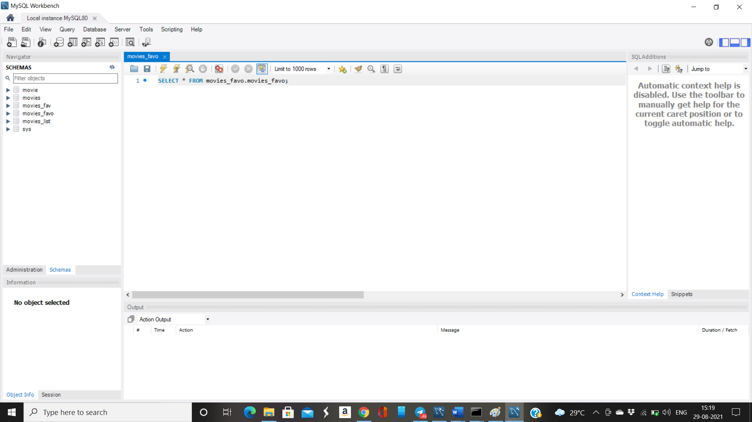

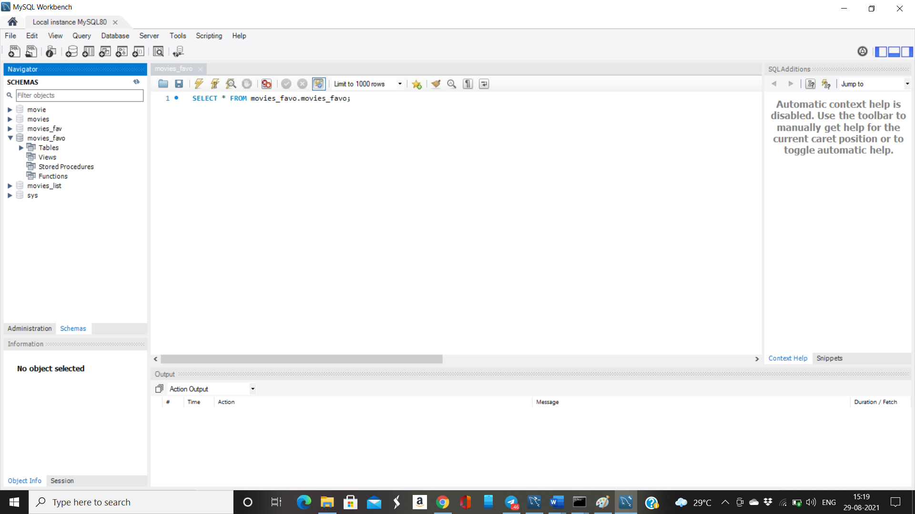

Click on tables: movies_favo

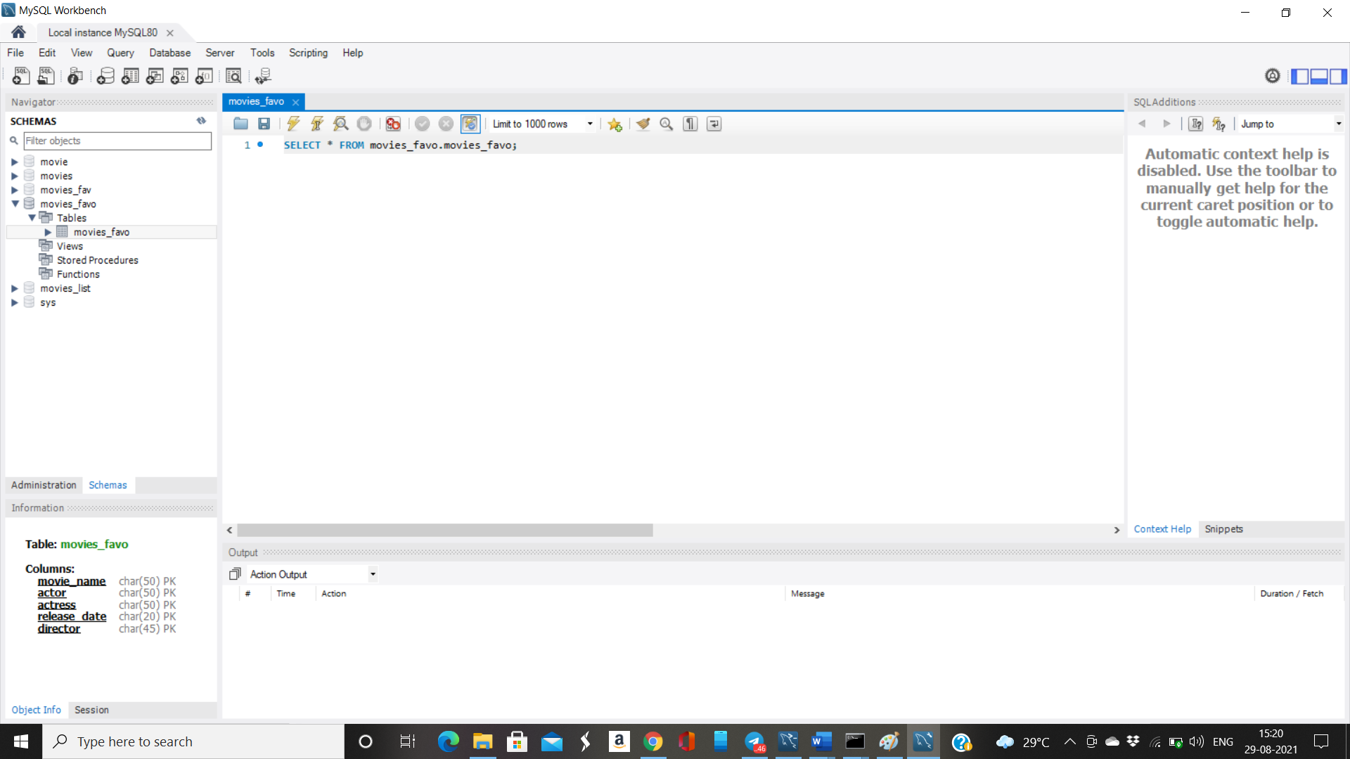

Click on to view the details of the tables

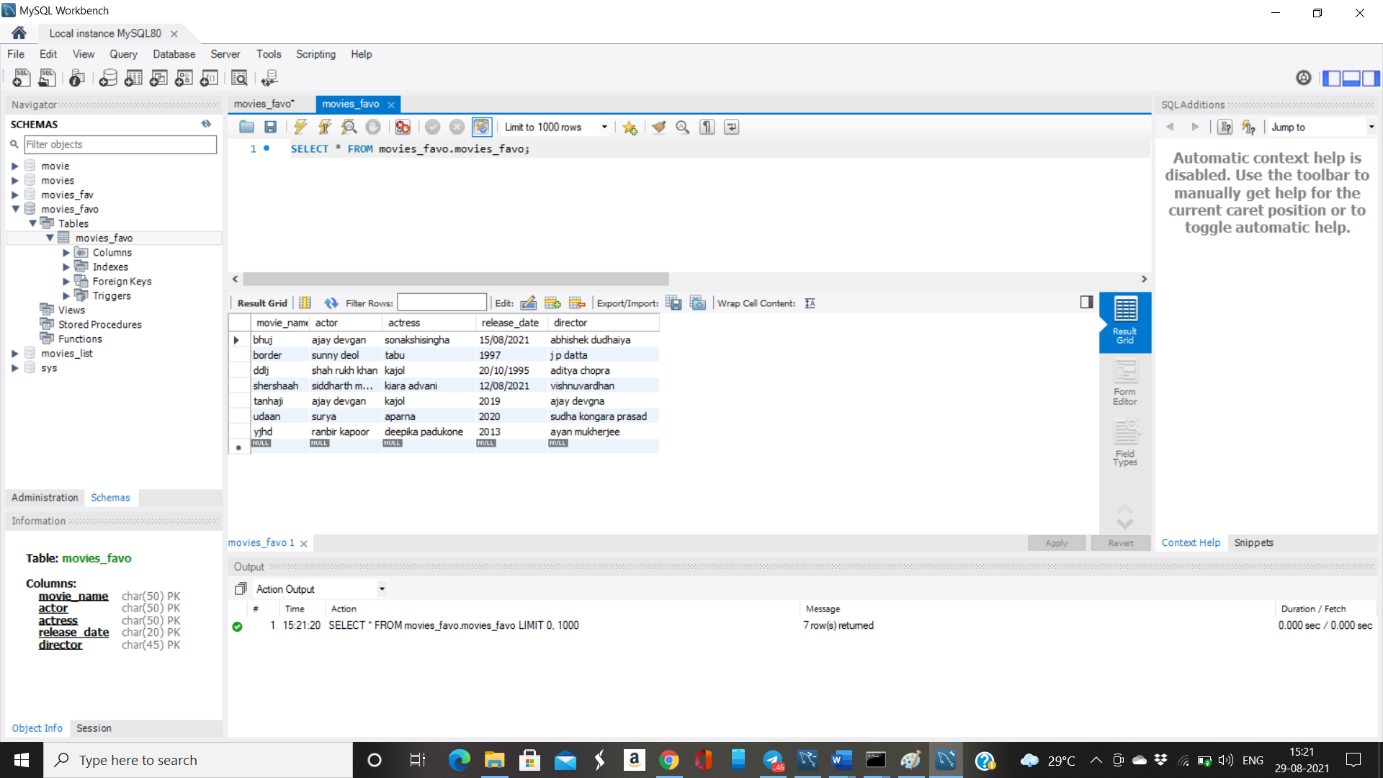

Thus the database is ready and now fetching data using python

